 | STS-6741  Wireless Emergency Pool Phone | 

Save money with an all-in-one wireless emergency pool phone.  The STS-6741 enables communities, builders, and property managers to keep using a dedicated pool emergency phone while migrating off copper. It is an all-in-one 4G/LTE solution — hardware, enclosure, power, and service — running on a dedicated wireless network. No landline. No trenching. Direct 911. | 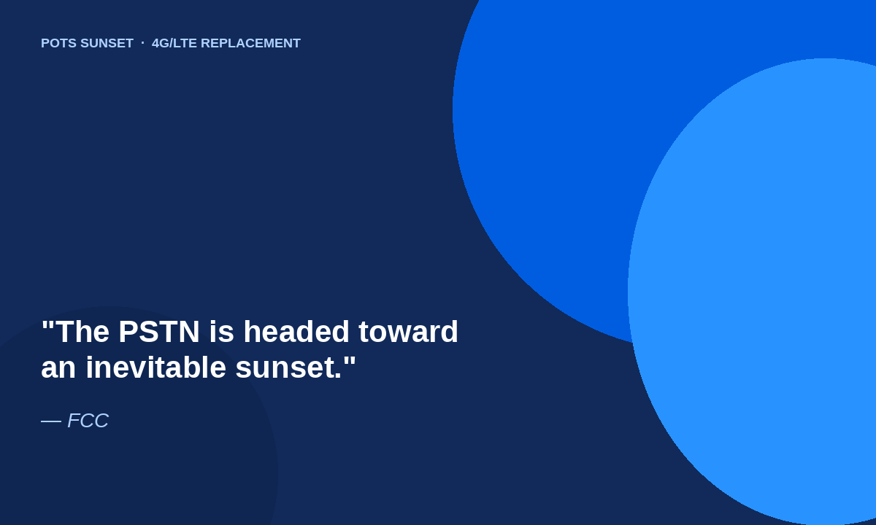

STS-6741 is ideal for: | 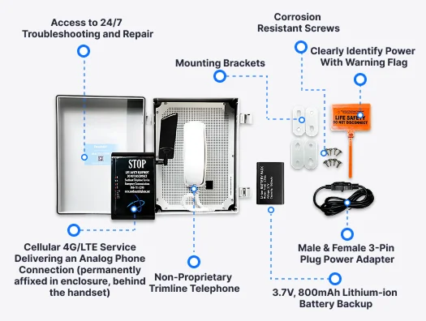
     | Commercial Pools
     | Multi-Tenant Community Pools
     | HOA / Clubhouse Pools
     | Apartment Complexes
     | New Commercial Construction
     | Existing Deck Retrofits
     | Builders & Contractors
     | Property Managers

Tremendous value  • Save money on customer monthly copper bills. Earn 75-100% one-time margins on equipment and 30-50% monthly recurring margins on service. | Compliance  • Designed to help communities meet emergency communication requirements for commercial and multi-tenant pools.
Simple migration  • A quick, easy migration — keep a familiar handset and retire the landline without tearing up the deck. | Easy install  • Attach to a wall near a standard 120V outlet. Four mounting screws. No electrician. No trenching.
No landline required  • Dedicated 4G/LTE cellular service eliminates copper, conduit, and trenching for new builds or retrofits. | Direct 911 connectivity  • Lift the handset and the call routes to local 911 dispatch — not a monitoring center or third-party service.
Weatherproof enclosure  • NEMA-rated IP66 housing built to withstand rain, humidity, pool chemicals, and outdoor exposure. | Battery backup  • 3.7V 800mAh lithium-ion backup helps maintain service during an unforeseen power event.
All-inclusive solution
• Phone, enclosure, adapter, and service from one provider — with 24/7 troubleshooting and repair.

Save money with the STS-6741. Call 866-711-3398 today for more information.

STS-6741
Complete Kit · How It Works

Everything You Need, Ready to Go  Includes phone, enclosure, adapter, and service. $250 one-time equipment fee. Service plans from $19.99/month. | COMPLETE KIT  Self-install ready

What's in the enclosure
Weatherproof enclosure
NEMA-rated IP66 housing with clear door, engineered for rain, humidity, splash, and pool chemicals.
Non-proprietary trimline telephone
Familiar handset operation. Compliant in counties that prohibit push-button phones.
4G/LTE fixed wireless terminal
Permanently affixed in the enclosure, behind the handset. Delivers an analog FXS line over cellular.
Lithium-ion battery backup
3.7V, 800mAh pack for short power interruptions.
Male & female 3-pin power adapter
Plugs into a standard 120V outlet. No electrician required.
Mounting kit
Mounting brackets and corrosion-resistant screws. Hang so the middle of the unit is ~4 ft off the ground.
Life-safety power flag
Orange warning flag to clearly identify power — Do Not Disconnect.
24/7 troubleshooting & repair
Access to SouthEast Telephone support after activation.

STS-6741 Solution Diagram
Lift the handset. The STS-6741 places the call over 4G/LTE. Emergency calls use a carrier-grade E911 routing network with nationwide PSAP coverage and dispatchable location delivery. Dispatch receives the registered pool name, physical address, and callback number — the same way a landline does.
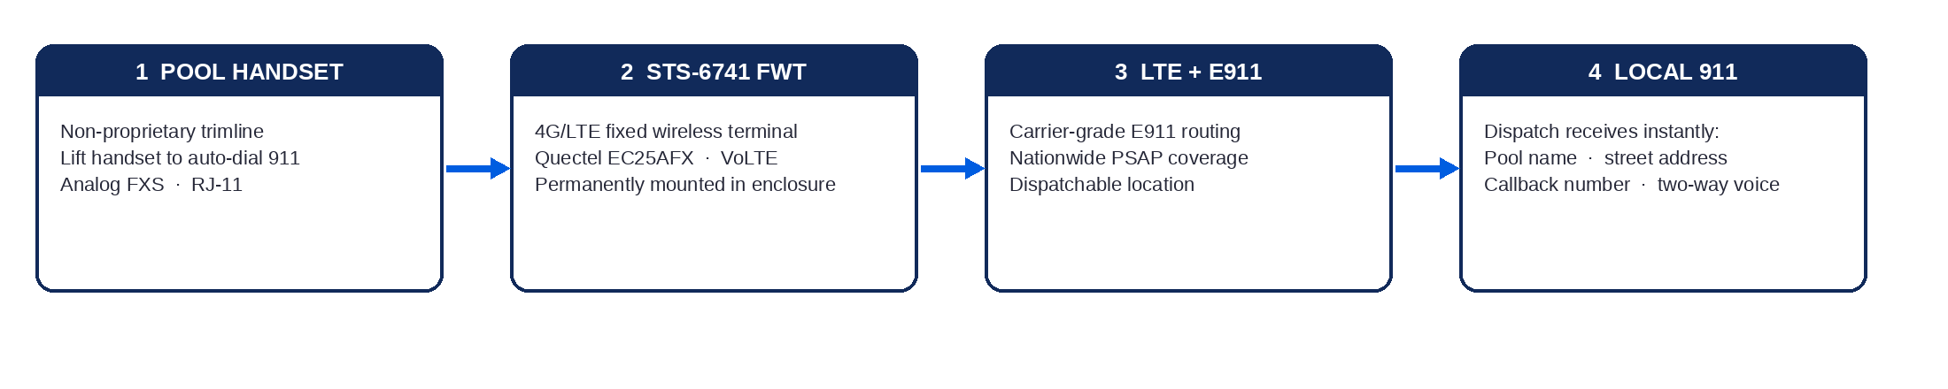

Direct 911 · No monitoring center · Landline-style name, address, and callback delivery.

STS-6741
Direct 911 · Installation · Compliance

Direct 911 with landline-style location delivery.
Most wireless pool phones rely on a prerecorded audible message or a third-party monitoring center that looks up the address and relays it. The STS-6741 does neither. Emergency calls use a carrier-grade E911 routing network with nationwide PSAP coverage and dispatchable location delivery, so dispatchers receive the correct information instantly.

What dispatch receives  • Registered pool / property name  • Physical street address  • Callback number tied to the device  • Two-way voice from the handset | What inspectors look for  • Dedicated emergency access  • Handset operation (where required)  • Clear two-way audio  • Direct 911 dialing  • Accurate location delivery  • Visible, accessible placement | What this is — and is not  • Pool emergency phones  • Elevator emergency phones  • Building safety phones / call boxes  • Not for fire-alarm FACP lines  • No added monitoring required  • Coverage not available everywhere

Fast, professional-grade deployment  Designed for quick installation and activation by builders, contractors, and property managers. Most customers self-install. Professional installation is available on request.  01 Attach each standoff / mounting bracket to the corners behind the weatherproof box.  02 Hang the unit so the middle is approximately 4 ft off the ground. Use a level.  03 Secure the power cord, run it through a wall, or use wire covering from a hardware store.  04 Plug into a standard 120V outlet. Turn the unit on with the power switch inside. Wait five full minutes.  05 SouthEast Telephone must confirm service activation before the unit will place emergency calls.  06 Because this is an auto-dial model, it will not place standard outgoing calls. It will accept inbound calls for a first test.  07 To complete testing, lift the handset — it auto-dials 911. Tell dispatch this is a test, not an emergency. They will confirm location, name, address, and phone number. | TURNKEY COMPLIANCE  Meet most state and local emergency phone regulations without copper.  Zero trenching  Ideal for new commercial pool construction or retrofitting existing decks.  Cost-effective  Introductory pricing that keeps the operating budget predictable.  Dependable network  4G/LTE cellular dedicated to emergency response.  Seasonal pools  Power down in the off-season and reactivate at opening.  Licensed  NC SP-FA/LV: 33766 · BBB A+ · 30+ years.

Emergency service will not work until system activation is confirmed by SouthEast Telephone.

STS-6741
Specifications

STS-6741 Specifications
Wireless module and analog telephony specifications from the 4G LTE FWT ETS-8848 platform. Enclosure, power, and kit details as shipped by SouthEast Telephone.
Wireless module | Quectel EC25AFX (USA); Cat-4 LTE. VoLTE supported. Industrial 4G LTE fixed-wireless module.
Frequency bands | 4G LTE FDD: B2 / B4 / B5 / B12 / B13 / B14 / B66 / B71. 3G WCDMA: B2 / B4 / B5.
Telephony | Two RJ-11 analog FXS outputs. Hanging voltage 45 V. Off-hook current 30 mA / 41 mA. Dial-tone frequency 450 Hz. Caller ID. DTMF / FSK. Polarity reversal for metering.
Antenna | SMA-female interface. Magnetic-base high-gain antenna with 3 m cable. Antenna gain > 2.5 dB. Sensitivity < −104 dBm.
SIM | Single SIM slot, 1.8 V / 3 V. Bottom-side access on the FWT.
Ethernet / data | Voice-primary FWT. Calls ride the carrier LTE network (VoLTE). Not a general-purpose router.
Power | AC adapter: input 110–240 VAC 50–60 Hz; output 5 VDC / 2 A. Standard 120 V outlet. Male & female 3-pin plug adapter included.
Battery backup | Replaceable Li-ion pack, 3.7 V, 800 mAh (included in the STS-6741 kit).
Enclosure | NEMA-rated IP66 weatherproof housing with clear door. Tamper-resistant. Corrosion-resistant screws. Life-safety power warning flag.
Handset | Non-proprietary trimline telephone. Auto-dial 911 on off-hook. Accepts inbound calls. Clear two-way audio.
FWT mechanical | ABS housing. 170 × 110 × 30 mm excluding antenna. Main unit weight 250 g. White / black.
Indicators & controls | LEDs: Power, In Use, In Talk, Battery, Signal strength (3). Power rocker switch. Factory restore via DTMF codes.
Environment | Operating −10 °C to 60 °C. Storage −20 °C to 70 °C. Humidity 45–95%. Atmospheric pressure 86–106 kPa.
911 / location | Emergency calls use a carrier-grade E911 routing network with nationwide PSAP coverage and dispatchable location delivery. Dispatch receives registered pool name, physical address, and callback number. No monitoring center.
Administration | DTMF function settings from the connected telephone (dial interval, earpiece/mic gain, CLIP, incoming-call barring, billing mode). Web portal is not required.
Service | Hardware + 4G/LTE voice service from SouthEast Telephone. Activation must be confirmed before emergency calling. Coverage not available everywhere.
Licensing | SouthEast Telephone Service, Inc. NC SP-FA/LV: 33766. 1032 W Academy St, Fuquay-Varina, NC 27526.

Service requires a compatible device. Coverage not available everywhere. Promotional equipment and service pricing available only to qualified customers. Requires a 36-month agreement. Subject to early termination fees. Taxes, fees, and other terms apply. $19.99/mo first 12 months; $39.99/mo remaining 24 months; $50.00/mo after the agreement on month-to-month terms, plus taxes and fees. Prices after discount with eligible AutoPay and paperless billing. The STS-6741 is not designed to replace analog lines for fire alarm control panel (FACP) communication. For your specific location, consult the local health department, building department, or an ADA expert, as AHJ enforcement can vary. © 2026 SouthEast Telephone Service, Inc.

Save money with the STS-6741. Call 866-711-3398 · southeasttelephone.net

